DOCKER[TASK-1]

1) Setup a virtual machine using Ubuntu image.

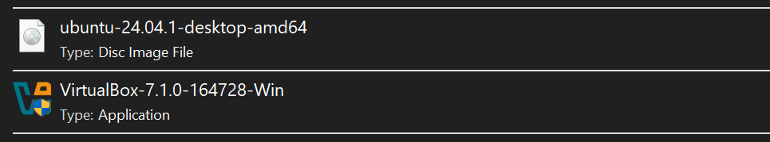

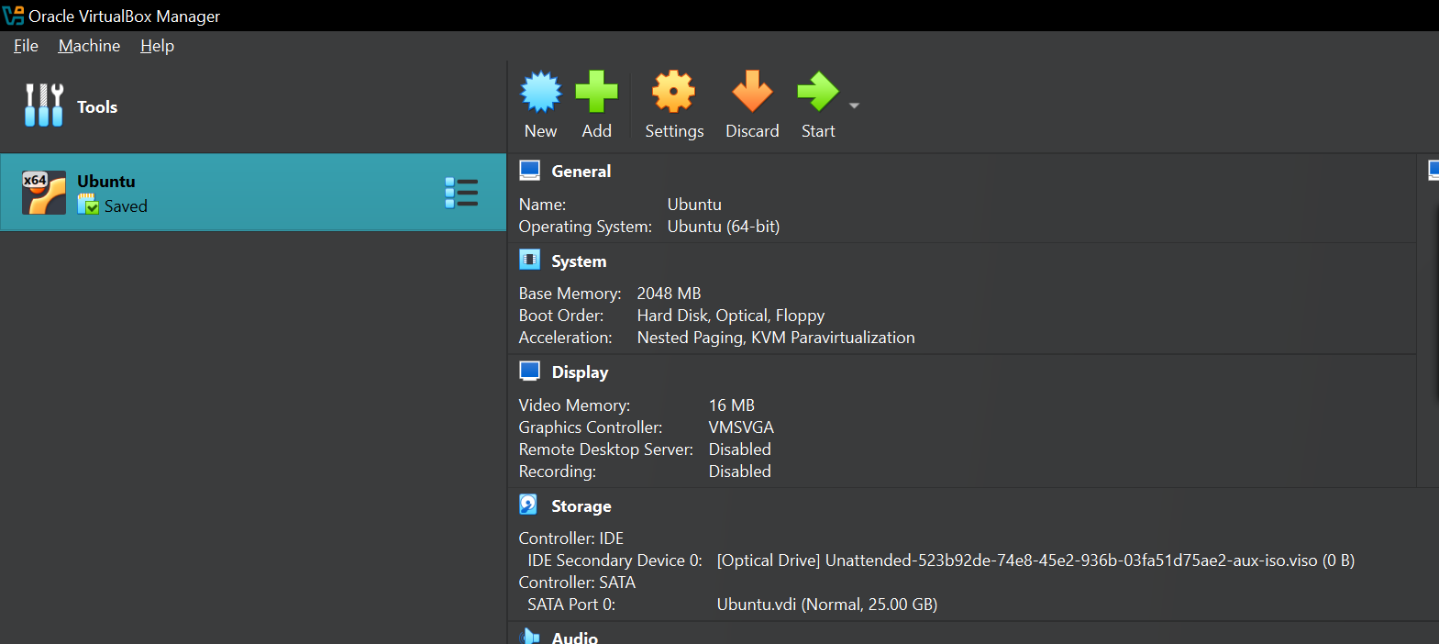

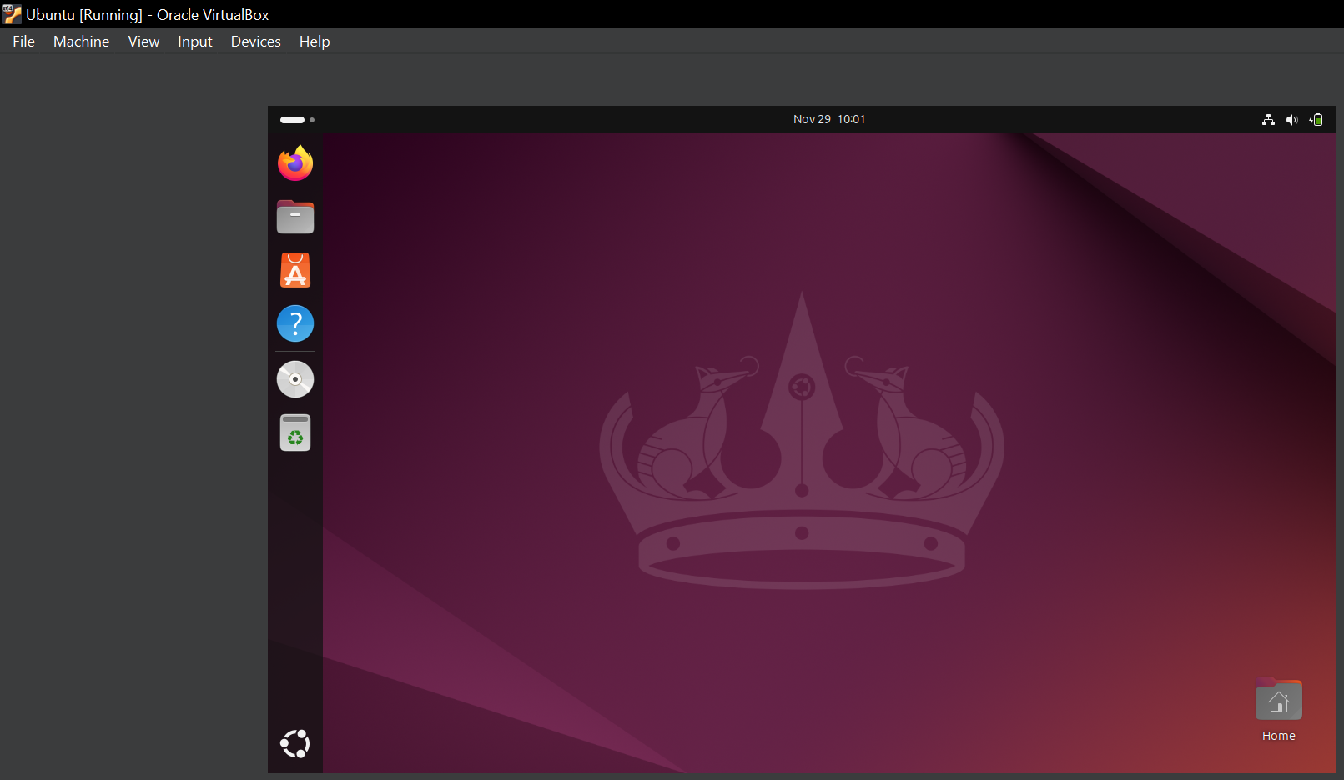

2) Install docker on ec2.

Installing the docker in ec2[yum install docker –y]

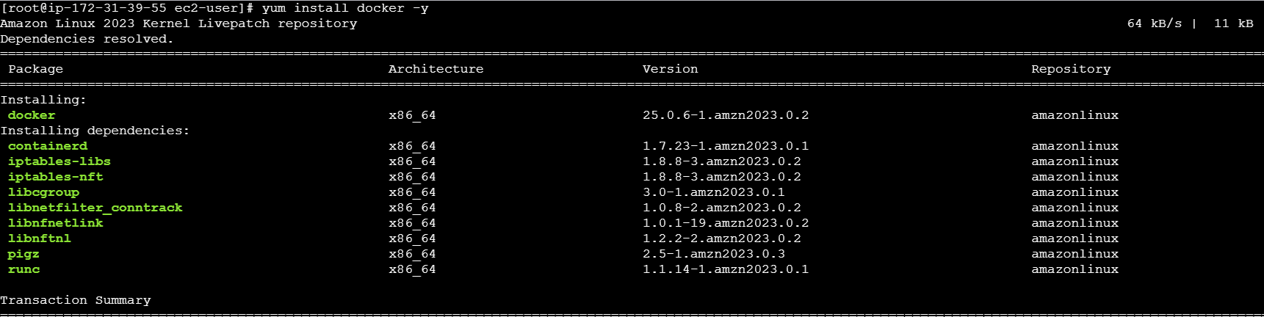

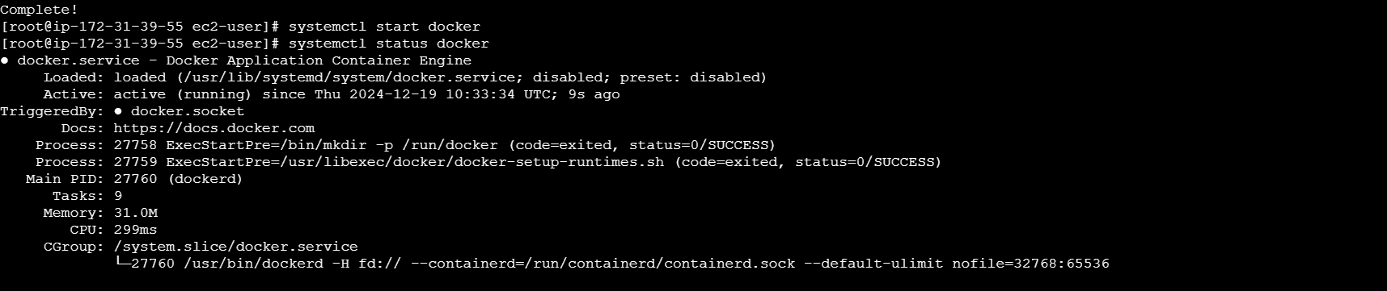

3) Pull 5 docker images.(nginx,apache tomcat,ubuntu,jenkins,sonarqube)

NGINX

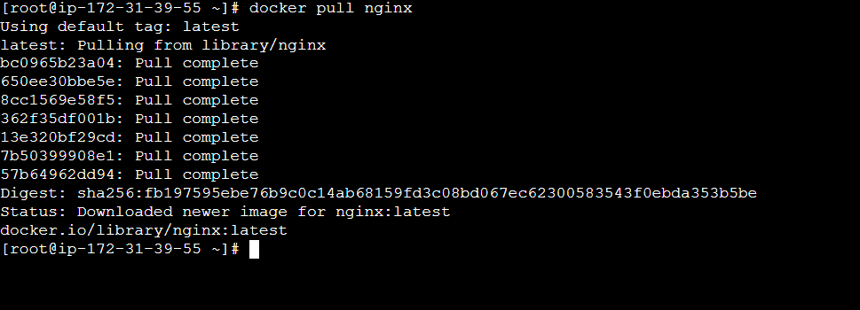

APACHE TOMCAT

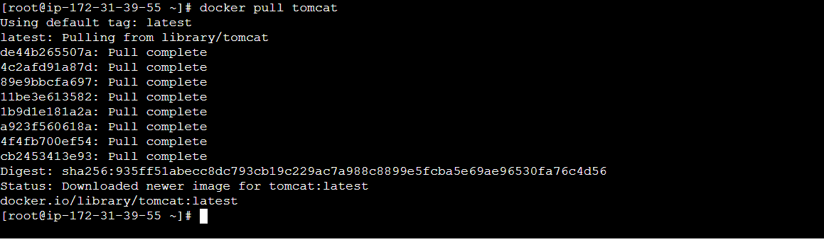

UBUNTU

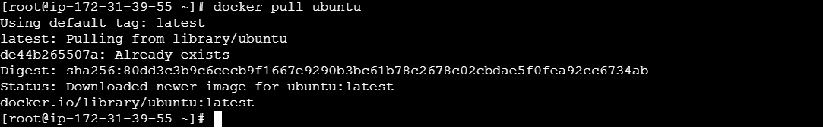

JENKINS

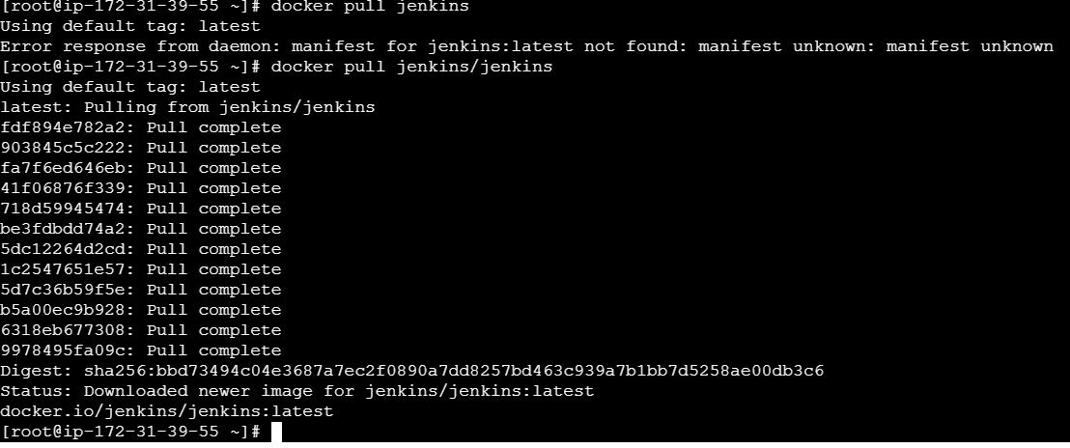

SONARQUBE

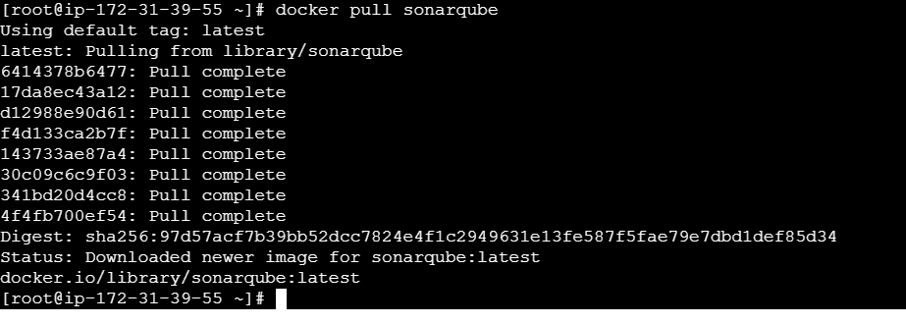

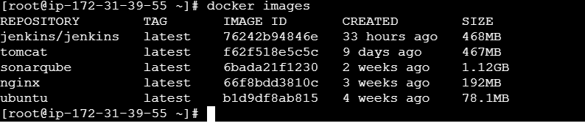

4) Run nginx container and expose on port 81.

Running the nginx container with the command

*docker container run –itd –p 81:80 –-name sample-container nginx*



Checking whether the ports number and name of the container has changed or not with command

*docker container ps*



The docker inspect command retrieves detailed information about Docker objects such as containers. It outputs data in JSON format, providing a comprehensive overview of the object's configuration and state.

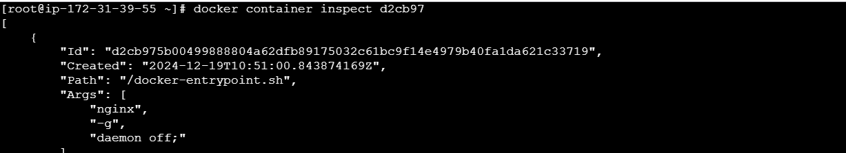

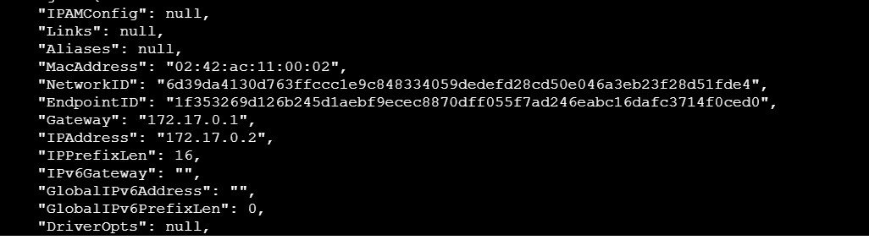

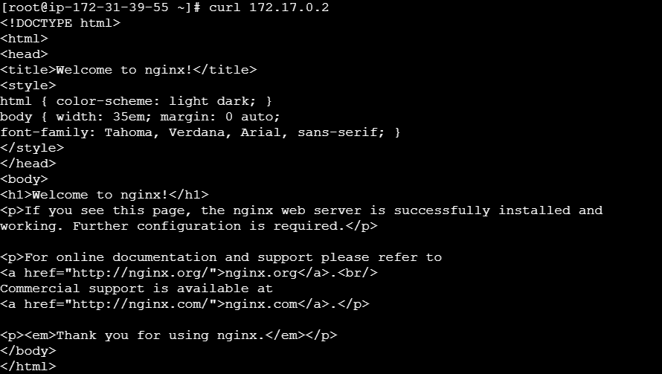

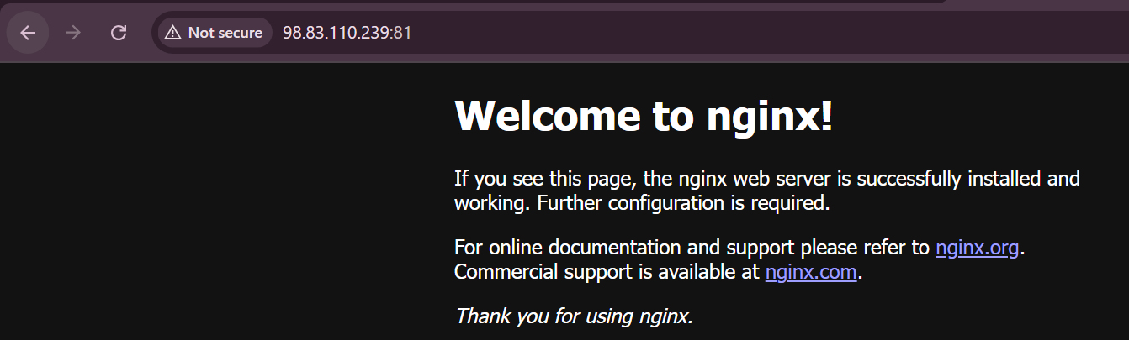

5) Delete the apache tomcat image from local.

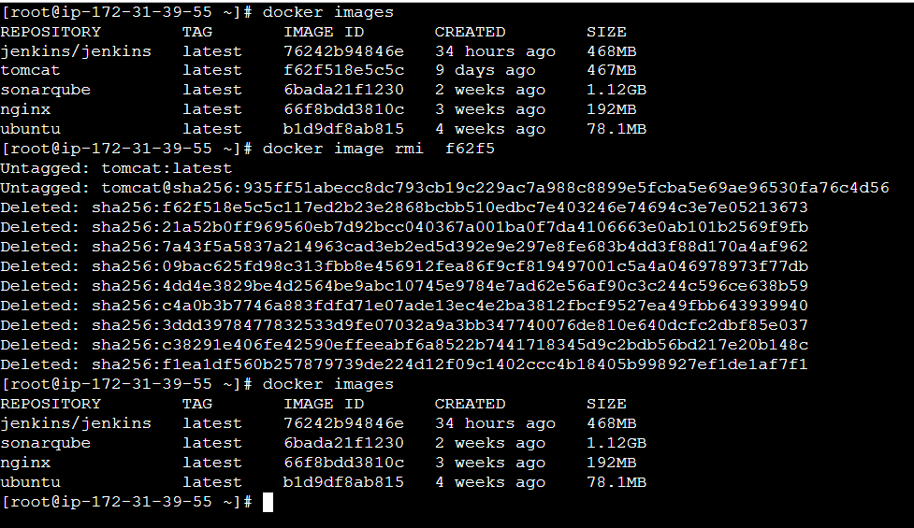

6) Inspect the jenkins image,sonarqube image.

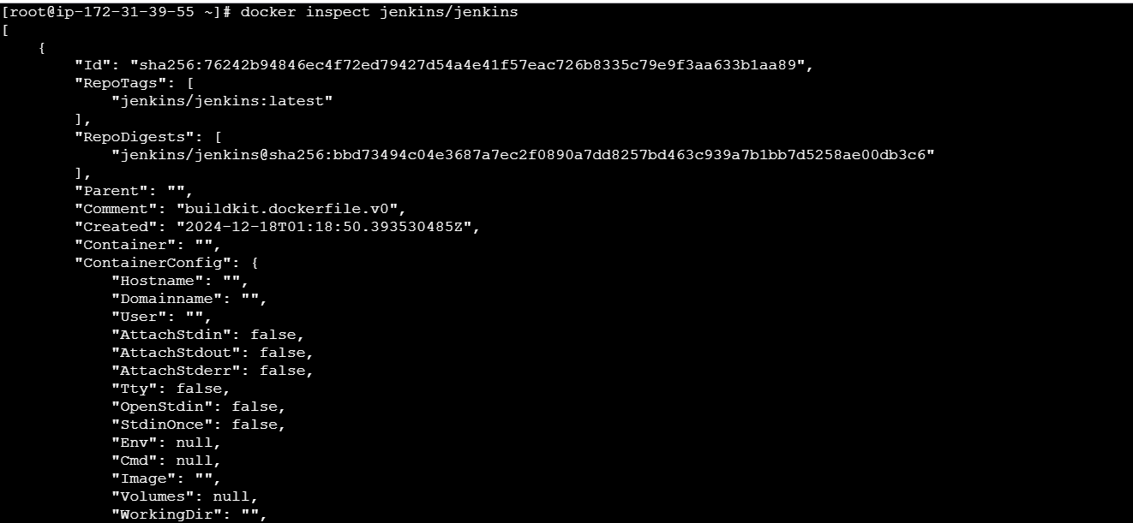

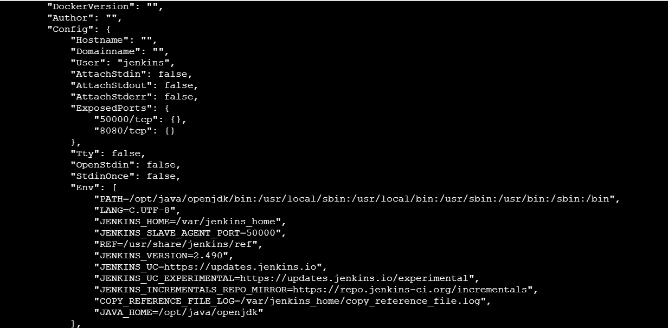

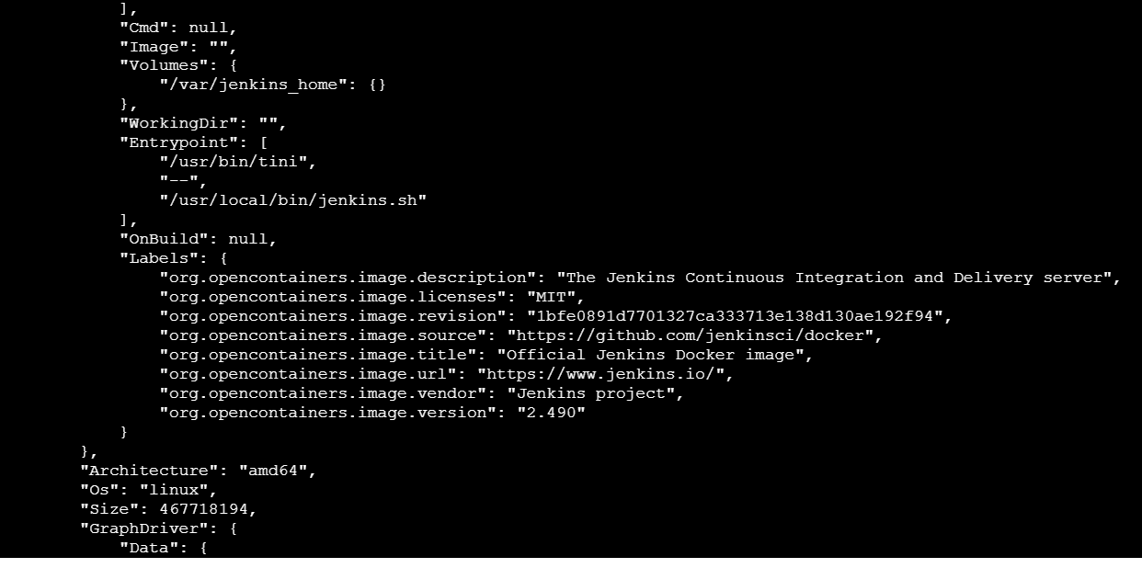

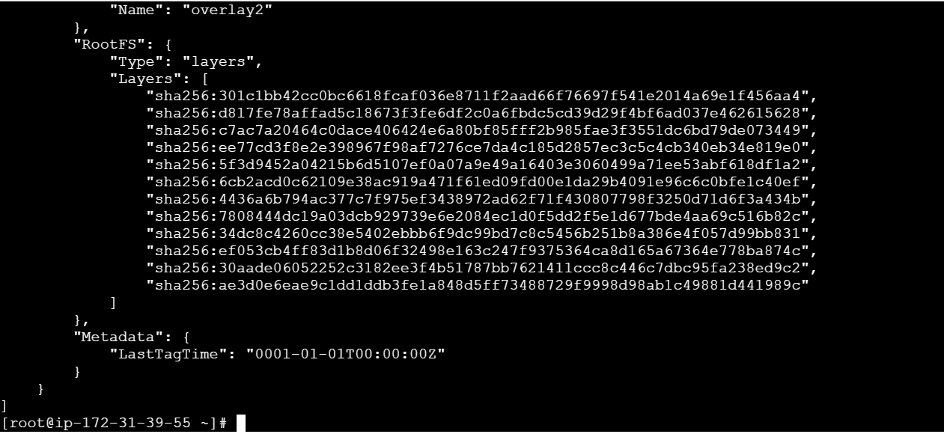

SONARQUBE

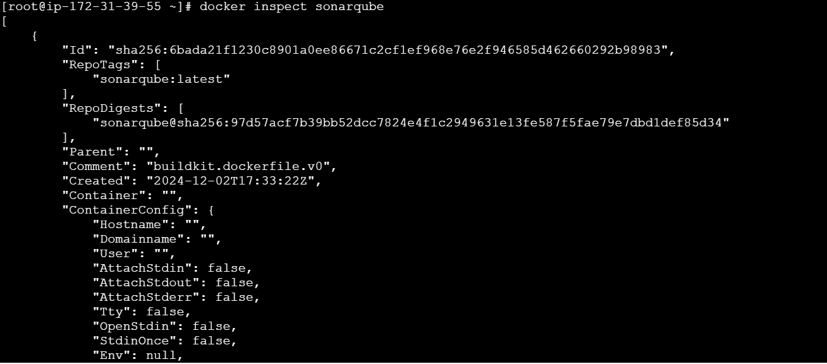

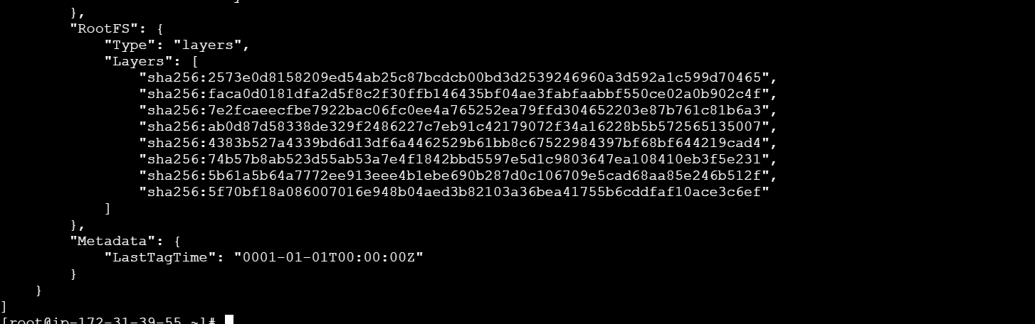

7) Run jenkins container and run one sample job.

